RAJALAKSHMI ENGINEERING COLLEGE,
THANDALAM, CHENNAI – 602 105



CS23621 – MOBILE APPLICATION DEVELOPMENT
LABORATORY

ONLINE EXPENSE TRACKER

A MINI-PROJECT REPORT SUBMITTED BY
MUSA HAJI (2116230701391)

IN PARTIAL FULFILMENT OF THE AWARD OF THE
DEGREE OF

BACHELOR OF ENGINEERING
IN
COMPUTER SCIENCE AND ENGINEERING
MAY 2026

RAJALAKSHMI ENGINEERING COLLEGE
(AUTONOMOUS)
RAJALAKSHMI NAGAR, THANDALAM – 602 105
BONAFIDE CERTIFICATE

Certified that this project titled “CLOUD EXPENSE TRACKER” is the bonafide work of Musa Haji (230701391), who carried out the project work under our supervision during the year 2026.

Signature
Dr. V. Karthick, M.E., (Ph.D.)
Associate Professor and Supervisor,
Department of Computer Science and Engineering, Rajalakshmi Engineering College, Thandalam.

Submitted to the Project for Examination held on .

Internal Examiner External Examiner
ABSTRACT

Cloud Expense Tracker is a comprehensive Android-based mobile application developed using Kotlin in Android Studio, designed to provide users with an intelligent, centralized, and real-time solution for managing their personal finances. In today's fast-paced world, individuals frequently struggle to maintain awareness of their spending habits, adhere to budgets, and plan savings effectively. This application addresses these challenges by offering a feature-rich platform that integrates expense tracking, budget management, analytics, savings goals, and debt management into a single, intuitive interface.
The application leverages cloud-based backend infrastructure to ensure that all financial data is securely synchronized across devices and accessible in real-time. Key modules include a Dashboard for financial overview, Transaction Management for recording income and expenses, Budget Management for defining and monitoring spending limits, Account Management for handling multiple bank accounts, and an Analytics module for visual monthly and category-wise analysis. Additional features such as Savings Goals, Debts and Lending tracking, Dark Mode, Theme Customization, and powerful Search and Filter capabilities further enhance the user experience.
The system is built using Kotlin as the primary programming language with Android Studio as the development environment, Firebase as the cloud backend for real-time data storage and user authentication, and XML-based layouts for a clean and responsive user interface. The application follows a modular architecture ensuring scalability, maintainability, and ease of future enhancement. Cloud Expense Tracker empowers users to take full control of their financial lives through a modern, reliable, and user-friendly mobile platform.

ACKNOWLEDGEMENT

Initially, we thank the Almighty for being with us through every walk of our life and showering his blessings through the endeavour to put forth this report. Our sincere thanks to our chairman Mr. S. MEGANATHAN, B.E, F.I.E., our respected Chairperson Dr. (Mrs.) THANGAM MEGANATHAN, Ph.D., our Vice Chairman Mr. ABHAY SHANKAR MEGANATHAN, B.E, M.S., for
providing us with the requisite infrastructure and sincere endeavouring in educating us in their premier institution.
Our sincere thanks to Dr. S.N. MURUGESAN, M.E., Ph.D., our beloved
principal for his kind support and facilities provided to complete our work in time. We express our sincere thanks to Dr. E. M. MALATHY, M.E., Ph.D., Professor and Head of the Department of Computer Science and Engineering and our mentor Dr. V. Karthick, M.E., Ph.D., Assistant Professor Department of Computer Science and Engineering for his useful tips during our review to build our project.

NAREN SURIYA V S (2116230701203)

TABLE OF CONTENTS

CHAPTER | TITLE | PAGE NO.
 | ABSTRACT | iii
 | ACKNOWLEDGEMENT | iv
 | LIST OF FIGURES | vi
1 | INTRODUCTION | 1
1.1 | General | 1
1.2 | Scope of the Work | 2
1.3 | Aim and Objectives of the Project | 3
1.4 | Proposed System | 4
2 | LITERATURE SURVEY | 6
3 | SYSTEM DESIGN | 8
3.1 | Architecture Diagram | 9
3.2 | Use Case Diagram | 10
3.3 | Activity / Workflow Diagram | 11
3.4 | Hardware Specifications | 12
3.4 | Software Specifications | 12
4 | PROPOSED SYSTEM | 15
4.1 | Overview of the Proposed System | 15
4.2 | System Description | 15
4.3 | Comparison with Existing Systems | 17
5 | PROJECT DESCRIPTION | 18
5.1 | Methodology | 18
5.2 | Modules | 20
5.3 | Technology Stack | 22
6 | CONCLUSION | 23
7 | REFERENCES | 26

LIST OF FIGURES

FIGURE NO. | TITLE | PAGE NO.
3.1 | Architecture Diagram | 9
3.2 | Use Case Diagram | 10
3.3 | Activity / Workflow Diagram | 11
6.2 | Application UI-Dashboard / Home Screen | 19
6.3 | Application UI-Transaction Management Screen | 19

CHAPTER 1
INTRODUCTION

1.1 General
In the contemporary digital era, effective personal financial management has emerged as a critical life skill for individuals across all socioeconomic backgrounds. With increasing consumer spending, rising cost of living, and the proliferation of digital payment methods, people are often unaware of exactly how much they spend, where their money goes, and whether they are on track to meet their financial goals. The absence of a centralized, real-time, and intelligent financial tracking tool often results in overspending, poor budget adherence, and financial stress.
Traditional methods of tracking expenses, such as manually maintaining spreadsheets or using paper-based ledgers, are not only cumbersome and error-prone but also lack the immediacy and analytical capabilities required for informed financial decision-making. While several financial applications exist in the market, many are either overly complex, not tailored to individual needs, or lack cloud synchronization capabilities that allow users to access their data across multiple devices.
The advancement of mobile technology and cloud computing has created unprecedented opportunities to address these challenges. Mobile applications equipped with cloud backends can provide real-time data synchronization, powerful analytics, and intelligent insights—all within the convenience of a smartphone. The Cloud Expense Tracker is conceptualized and developed to fill this gap by offering a comprehensive, cloud-integrated, and user-friendly Android application for personal financial management.
Developed using Kotlin and Android Studio, the Cloud Expense Tracker integrates a wide range of financial management features including expense and income tracking, budget management, savings goals, debt and lending tracking, monthly analytics, multi-account support, dark mode, and advanced search and filter capabilities. The application leverages Firebase as the cloud backend for real-time data storage and secure user authentication, ensuring that all financial records are reliably stored and accessible at any time.

1.2 Scope of the Work
The primary objective of the Cloud Expense Tracker is to develop a robust, cloud-integrated Android mobile application using Kotlin that provides users with a comprehensive and intelligent platform for managing their personal finances in an organized, real-time, and user-friendly manner.
The supporting objectives of the project are as follows:
- To design a clean, intuitive, and visually appealing user interface for seamless navigation.
- To enable users to record, categorize, and manage income and expense transactions effectively.
- To provide budget management features that allow users to set, monitor, and enforce spending limits across categories.
- To support multiple bank account management within a single platform.
- To deliver visual analytics and monthly reports for informed financial decision-making.
- To implement savings goals tracking to help users achieve their financial targets.
- To provide a debts and lending module for tracking money owed or lent.
- To integrate powerful search and filter capabilities for quick data retrieval.
- To support dark mode and customizable theme colors for personalized user experience.
- To implement secure user authentication using Firebase Authentication.
- To ensure real-time cloud synchronization of all financial data using Firebase Real-Time Database.

1.3 Aim and Objectives of the Project
Several personal finance and expense tracking applications are currently available in the market. Popular solutions such as Money Manager, Walnut, Spendee, and YNAB (You Need A Budget) provide various features including transaction logging, budget setting, and spending reports. Certain banking applications also embed basic expense tracking capabilities within their platforms.
However, most of these applications suffer from significant limitations that diminish their effectiveness for a broad user base. Many existing systems are either too simplistic, offering only basic transaction recording without meaningful analytics, or too complex, presenting an overwhelming interface that intimidates new users. Several prominent applications are paywalled, restricting essential features such as multi-account support, budget tracking, and analytics to premium subscribers.
Disadvantages of the Existing System
- Many applications lack comprehensive cloud synchronization, making data inaccessible across multiple devices.
- Core features such as savings goal tracking and debt management are often available only through paid subscriptions.
- Most applications do not provide integrated debts and lending management alongside expense tracking.
- Complex and cluttered interfaces reduce usability for non-technical users.
- Limited search and filter functionalities make retrieving specific transactions difficult.
- Many existing solutions do not support multi-account management in a unified view.
- Lack of theme customization and dark mode support in budget-oriented applications.
- Insufficient analytics depth, with most apps offering only basic category-wise breakdowns.

1.4 PROPOSED SYSTEM
The proposed system, Cloud Expense Tracker, is a comprehensive Android mobile application developed using Kotlin and Android Studio, backed by Firebase for cloud data management and authentication. The application is designed to serve as an all-in-one personal finance management solution, combining expense tracking, budget management, analytics, savings goals, debt tracking, and multi-account support within a single, seamlessly integrated platform.
Users can register and log in securely through Firebase Authentication. Upon authentication, they are directed to a dynamic Dashboard that provides a real-time overview of their financial status, including total balance, recent transactions, and budget utilization. All financial data is stored and synchronized in real-time via Firebase Real-Time Database, ensuring that the latest information is always available regardless of the device being used.

Key Features of the Proposed System
- Dashboard / Home with real-time financial overview and quick access navigation.
- Transaction Management for recording, categorizing, and editing income and expense entries.
- Budget Management with category-wise budget setting, monitoring, and alert notifications.
- Account Management supporting multiple bank accounts with individual balance tracking.
- Analytics module with visual charts for monthly trends and category-wise spending analysis.
- Savings Goals module for defining, tracking, and achieving financial targets.
- Debts and Lending tracker for monitoring amounts owed to and by the user.
- Settings and Customization including notification preferences and profile management.
- Dark Mode and Theme Color customization for a personalized visual experience.
- Search and Filters for efficient retrieval of transactions by date, category, or keyword.
- Multiple Bank Account support within a unified financial dashboard.
- Expense and Income Tracking with historical records and summary views.

Advantages of the Proposed System
- Integrates all essential personal finance tools within a single mobile platform.
- Real-time cloud synchronization ensures data availability across devices.
- Eliminates dependency on manual record-keeping through automated transaction management.
- Provides deep financial insights through visual analytics and trend reports.
- Supports multi-account management, making it suitable for users with diverse banking needs.
- Beginner-friendly interface with intuitive navigation and clean layout design.
- Free core features without mandatory subscription requirements.
- Secure authentication and cloud data storage via Firebase infrastructure.

.CHAPTER 2

LITERATURE SURVEY
A comprehensive literature review was conducted to understand the current state of personal finance management applications, cloud-based mobile architectures, and user interface design principles relevant to financial tools. Research studies, technical documentation, and existing application analyses were examined to identify the best practices and technological approaches for developing the Cloud Expense Tracker.
Studies on mobile-based personal finance management have consistently highlighted the growing demand for integrated financial tracking solutions that combine simplicity with analytical depth. Research published in the domain of mobile computing has demonstrated that users significantly improve their financial habits when equipped with real-time tracking, visual analytics, and timely alerts. These findings validated the inclusion of a comprehensive analytics module and budget alert notifications within the proposed system.
An analysis of cloud integration strategies for Android applications revealed that Firebase Real-Time Database offers the most suitable combination of real-time data synchronization, NoSQL flexibility, and scalability for applications of this nature. Firebase Authentication was identified as a secure and developer-friendly solution for user identity management, supporting email-based and OAuth-based login flows with minimal implementation overhead.
Existing research on user interface design for financial applications emphasized that clarity, minimal cognitive load, and consistent visual hierarchy are critical for user retention. Studies specifically noted that dashboard-centric designs, where key financial metrics are immediately visible upon login, significantly improve user engagement and daily usage consistency. These principles directly influenced the dashboard and navigation architecture of the Cloud Expense Tracker.
Research into multi-account financial management applications revealed that users with multiple banking relationships particularly value unified views that aggregate balances and transactions across accounts. The literature supported the development of the Account Management module, which provides consolidated visibility across all linked bank accounts.
Studies on savings behavior and digital tools found that users who set explicit, trackable savings goals demonstrate significantly higher rates of goal achievement compared to those without structured targets. This research motivated the inclusion of a dedicated Savings Goals module within the application, providing users with progress tracking and motivational visual indicators.
The technical documentation of Firebase Real-Time Database, Firebase Authentication, Kotlin Coroutines, Android Jetpack components, and XML layout design provided comprehensive implementation guidance. Official documentation from the Android Developers platform, Firebase Developer Guides, and Kotlin language references were extensively consulted during the design and development phases.
Overall, the literature review provided critical insights into cloud architecture patterns, financial data modelling, user interface design for finance applications, notification systems, and multi-account management strategies—all of which were incorporated into the design and development of the Cloud Expense Tracker.

CHAPTER 3

SYSTEM DESIGN

The Cloud Expense Tracker follows a client-server architecture model where the Android mobile application acts as the client and Firebase provides the backend server services including real-time database management and user authentication. The application is structured using a modular architecture, where each functional component operates independently while communicating with shared data and navigation layers.
The system architecture consists of three primary layers:

1. Presentation Layer (UI Layer)
The presentation layer encompasses all user interface components including activities, fragments, navigation elements, recycler views, charts, and input forms. Designed using XML layouts in Android Studio, this layer handles all user interactions including transaction entry, dashboard viewing, budget monitoring, analytics visualization, and settings management. A consistent Material Design language is applied throughout to ensure visual coherence and accessibility.

2. Application Logic Layer (Business Layer)
The application logic layer manages all data processing operations within the application. It handles transaction validation, budget threshold calculations, savings goal progress computation, analytics data aggregation, search and filter operations, and multi-account balance reconciliation. Kotlin-based ViewModel and Repository patterns maintain a clean separation of concerns, ensuring that business logic remains decoupled from the UI layer.
3. Data Layer (Firebase Cloud Backend)
The data layer comprises Firebase services responsible for all backend operations. Firebase Real-Time Database stores all application data including user profiles, transaction records, budget configurations, account details, savings goals, and debt entries in a structured NoSQL format. Firebase Authentication manages secure user registration, login, and session management. The data layer ensures real-time synchronization across devices, guaranteeing that the user's financial data is always current and consistent.
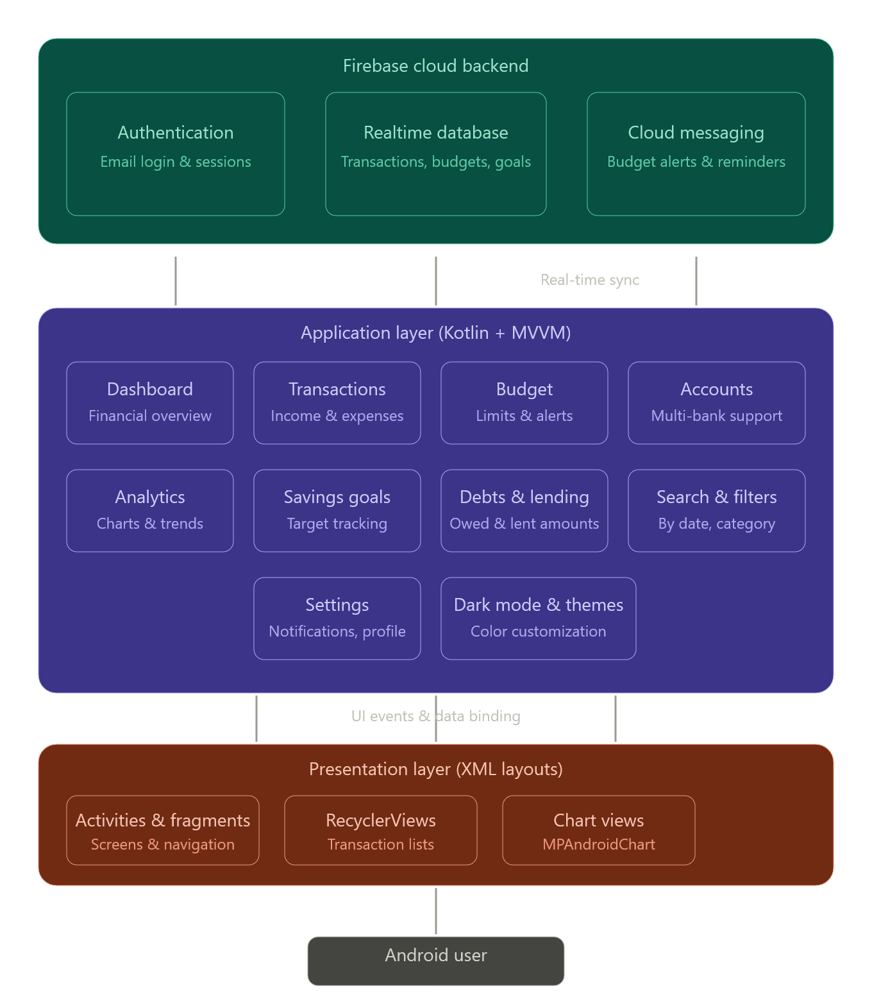
[Figure 3.1: System Architecture Diagram]

3.2 USE CASE DIAGRAM
The Use Case Diagram illustrates the functional interactions between the primary system actors and the application modules. The principal actors in the Cloud Expense Tracker system are the Registered User and the Firebase Backend System.
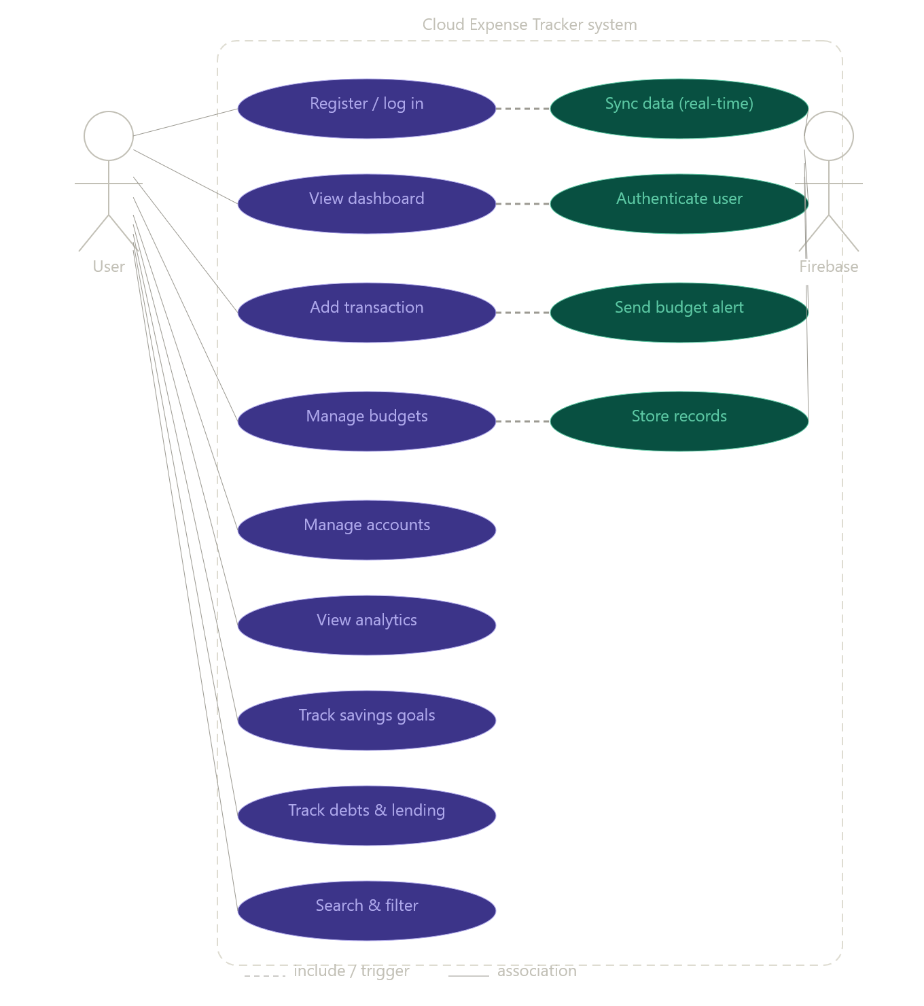
[Figure 3.2: Use Case Diagram]

3.3 ACTIVITY / WORKFLOW DIAGRAM
The Activity and Workflow Diagram describes the sequence of operations performed within the Cloud Expense Tracker from user authentication through to core financial management activities.
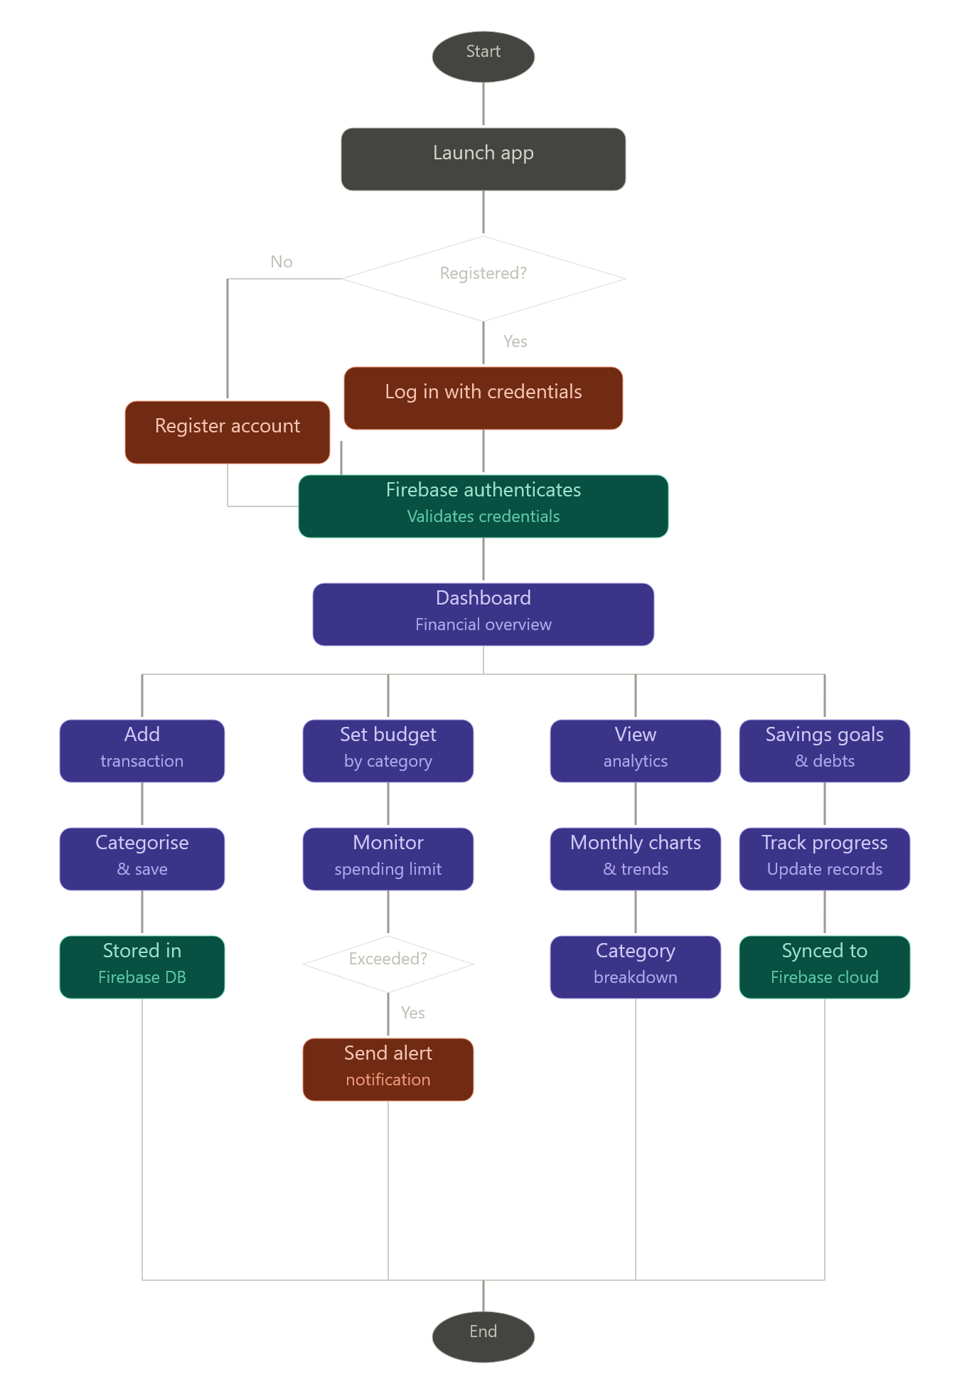
[Figure 3.3: Activity / Workflow Diagram]

3.3 HARDWARE SPECIFICATIONS

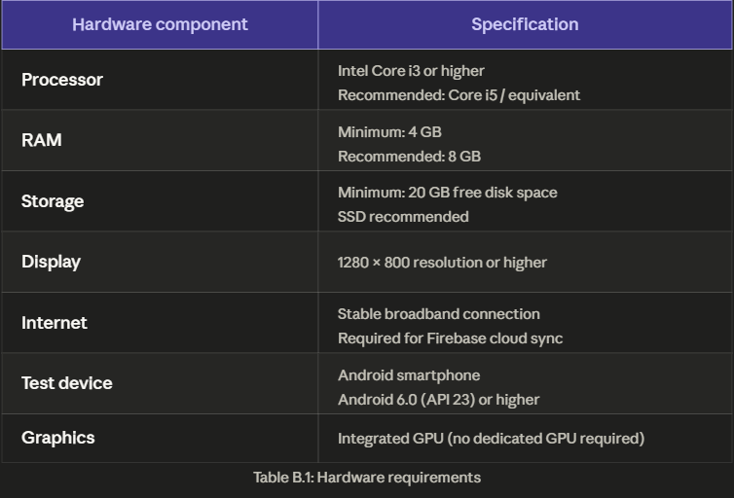

3.4 SOFTWARE SPECIFICATIONS

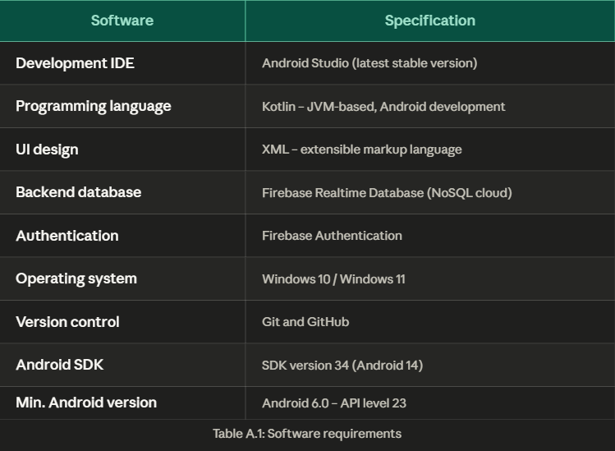

Frontend Software Requirements

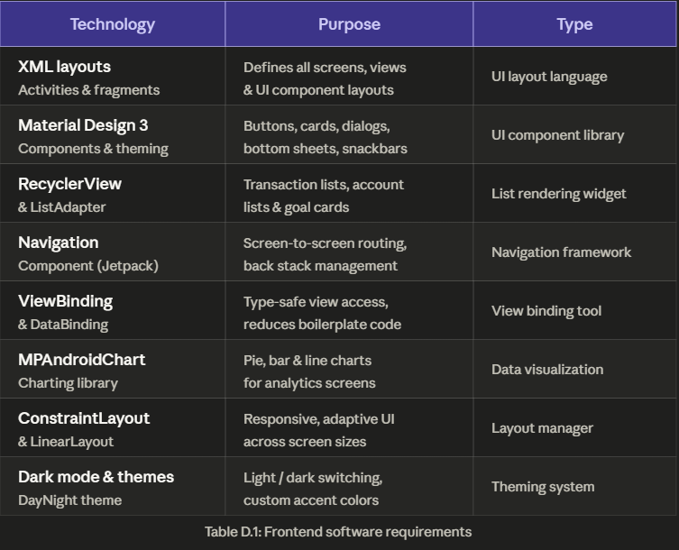

Backend Software Requirements

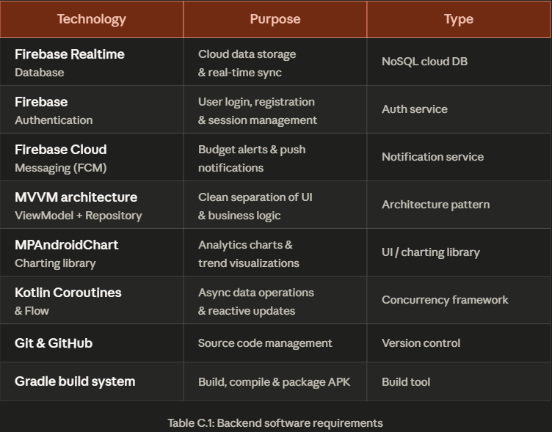

Database Requirements
- Database System: Firebase Realtime Database / Cloud Firestore
- Data Storage: Cloud-based database system
The database stores structured data such as student details, driver information, bus routes, schedules, notifications, and transport management records, ensuring efficient organization, secure access, and quick retrieval of information.

Third-Party APIs and Services
Cloud Backend Services: Firebase
- Authentication and Database Services: Firebase Authentication and Cloud Firestore.
- Real-Time Communication Services: Firebase Realtime Database / Cloud Messaging.
These services are used to manage user authentication, store transportation data, enable real-time synchronization, and improve communication between students, drivers, and administrators within the transport management system.

Version Control
- Platform: Git
- Repository Hosting: GitHub
Version control is used to manage source code, track changes, and enable collaborative development.

Operating System Requirements
- Development: Windows / macOS / Linux
- Deployment: Android Operating System (Version 8.0 and above)

Other Supporting Tools
- Package Manager: Gradle
- API Testing Tools: Postman (optional)
- Emulator: Android Emulator / Physical Device

CHAPTER 4

PROPOSED SYSTEM
4.1 OVERVIEW OF THE PROPOSED SYSTEM
The proposed system, Cloud Expense Tracker, is a comprehensive Android mobile application developed using Kotlin and Android Studio, backed by Firebase as the cloud backend for real-time data management and secure user authentication. The application is designed to serve as a complete, all-in-one personal finance management solution that integrates expense and income tracking, budget management, multi-account support, savings goals, debt and lending management, visual analytics, and advanced search and filter capabilities within a single, unified mobile platform.
The system addresses the key limitations of existing financial management tools by combining all essential features into one seamless experience, eliminating the need for users to switch between multiple applications to manage different aspects of their finances. All financial data is stored and synchronized in real time through Firebase Realtime Database, ensuring that records are always current, consistent, and accessible from any device.
4.2 SYSTEM DESCRIPTION
Upon launching the application, users are presented with a secure login or registration screen powered by Firebase Authentication. New users complete a simple registration process using their email address and password, while returning users authenticate using their existing credentials. Once authenticated, users are directed to the main Dashboard, which serves as the central hub of the application.
The Dashboard provides a real-time financial overview including total balance, total income, total expenses for the current period, budget utilization summary, and quick navigation links to all key modules. The dashboard is designed to give the user an immediate and comprehensive picture of their financial health without requiring any additional navigation.
From the Dashboard, users can seamlessly navigate to any of the application's functional modules. The Transaction Management module allows users to record income and expense entries with full details including amount, category, description, date, and associated bank account. All recorded transactions are instantly synchronized to Firebase Realtime Database and immediately reflected across the dashboard balance and analytics views.
The Budget Management module enables users to define monthly spending limits for individual expense categories. The system continuously monitors recorded transactions against defined budget thresholds and triggers alert notifications through Firebase Cloud Messaging when spending approaches or exceeds the set limit, promoting disciplined financial behaviour without requiring the user to manually check their spending.
The Account Management module supports the addition and management of multiple bank accounts within a single unified view. Each account maintains an independent balance and transaction history, and the dashboard aggregates all accounts to present a consolidated financial overview. This feature is particularly valuable for users who manage finances across multiple banking relationships.
The Analytics module delivers rich visual representations of the user's financial data, including monthly income and expense trend line charts, category-wise expenditure pie charts, and period-over-period comparative analysis. These visualizations are rendered using MPAndroidChart and are designed to help users identify spending patterns, track financial progress, and make informed budgeting decisions based on historical data.
The Savings Goals module allows users to define specific financial targets with designated goal amounts and target completion dates. Users can allocate contributions toward active goals and monitor progress through visual progress indicators. The module is designed to motivate consistent saving behaviour by providing clear, real-time visibility into how close the user is to achieving each financial objective.
The Debts and Lending module provides a structured interface for recording and tracking amounts owed to others as well as amounts lent to others. Each entry includes the counterparty name, amount, due date, and repayment status, ensuring that users maintain accurate records of all financial obligations and receivables without relying on informal memory or external notes.
The Search and Filters module provides users with powerful tools to retrieve specific transactions from their financial history. Users can search by keyword and apply filters based on transaction type, category, date range, and associated bank account. This functionality ensures that even large transaction histories remain easily navigable and that specific records can be located quickly and efficiently.
The Settings and Customization module provides users with control over notification preferences, currency settings, and profile management. The Dark Mode and Theme Colors module enables users to switch between light and dark display modes and select from a palette of accent colors, ensuring a personalized and visually comfortable experience.
4.3 COMPARISON WITH EXISTING SYSTEMS
Feature | Existing systems | Cloud Expense Tracker
Integrated booking + tracking | Separate apps required | Single unified platform
Real-time cloud sync | Limited or paywalled | Full Firebase sync
Multi-account support | Premium only | Included by default
Budget alerts | Basic or absent | FCM push notifications
Visual analytics | Limited charts | Full MPAndroidChart views
Savings goals tracking | Absent or premium | Built-in module
Debts and lending | Not available | Dedicated module
Dark mode and themes | Rarely available | Fully supported
Search and filters | Basic keyword only | Multi-criteria filtering
Free core features | Heavily paywalled | Fully free core access

CHAPTER 5
PROJECT DESCRIPTION

5.1 METHODOLOGY
The Cloud Expense Tracker is developed following the Agile development methodology, which emphasizes iterative development, continuous testing, and incremental delivery of working features. The Agile approach allows for flexible adaptation to evolving requirements and ensures that each phase of development produces a functional and testable component of the application.
The development process is structured into five phases:
- Requirement Analysis – Identifying user needs, defining functional and non-functional system requirements, and studying existing financial applications to determine the optimal feature set.
- System Design – Creating UI wireframes, designing the system architecture, defining the Firebase database schema, and planning the modular application structure.
- Development – Implementing all functional modules including authentication, dashboard, transaction management, budget management, account management, analytics, savings goals, debts tracking, search and filters, and settings and customization.
- Testing – Conducting unit testing, integration testing, and UI performance testing across all modules; identifying and resolving bugs; optimizing data retrieval and rendering performance.
- Deployment – Finalizing the application, validating functionality on real Android devices and emulators, and preparing the project report and demonstration.

This structured and iterative approach ensures that each module of the application is developed, tested, and integrated systematically, resulting in a reliable, complete, and high-quality final product.

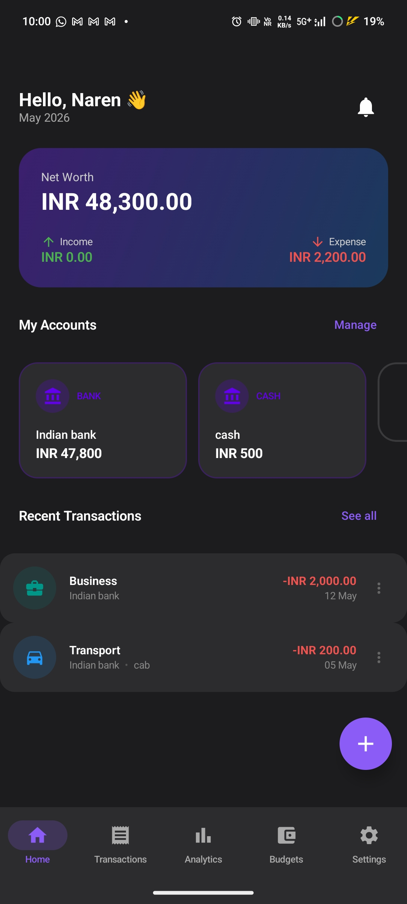
[Figure 4.1: Application UI Wireframe – Dashboard / Home Screen]
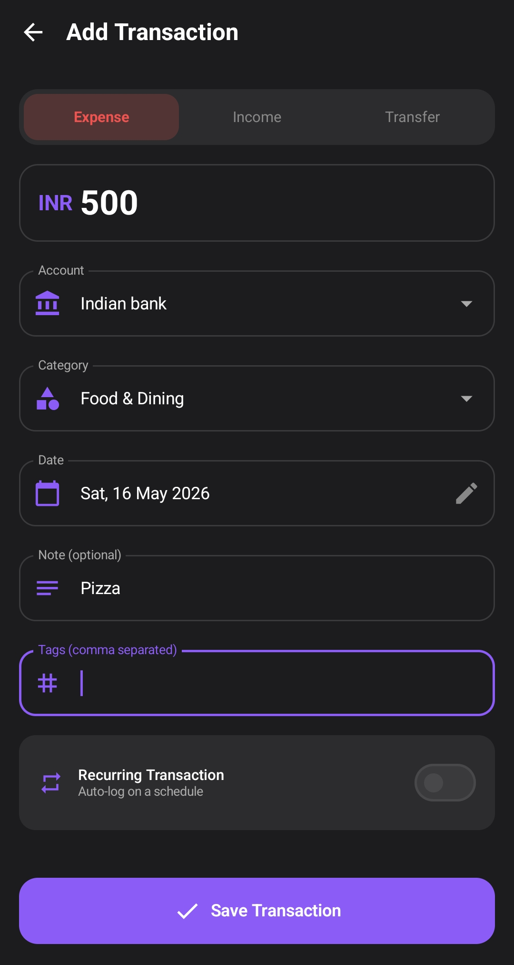
[Figure 4.2: Application UI Wireframe – Transaction Management Screen]

5.2 MODULES
The Cloud Expense Tracker is organized into thirteen functional modules. Each module handles a specific set of financial management responsibilities and interacts with the shared Firebase backend and navigation framework.
Module 1: Dashboard / Home Module
The Dashboard Module serves as the central hub of the application. Upon login, users are presented with a real-time financial overview including total balance, total income, total expenses, recent transactions, budget utilization summary, and quick-access navigation links to all key modules. The dashboard is designed for immediate comprehension of the user's current financial health.
Module 2: Transaction Management Module
The Transaction Management Module enables users to record, view, edit, and delete income and expense transactions. Each transaction entry includes the amount, type (income or expense), category, description, date, and associated bank account. Transactions are stored in real-time to Firebase and immediately reflected across the dashboard and analytics modules.
Module 3: Budget Management Module
The Budget Management Module allows users to define monthly spending limits for individual expense categories. The system continuously monitors recorded transactions against the defined budget limits and provides visual progress indicators. Alert notifications are triggered when spending approaches or exceeds the set budget threshold for any category, promoting disciplined financial behaviour.
Module 4: Account Management Module
The Account Management Module supports the addition and management of multiple bank accounts within the application. Each account maintains an individual balance, transaction history, and account type designation. The module provides a consolidated view of all linked accounts, enabling users with diverse banking relationships to manage all finances within a single platform.
Module 5: Analytics Module
The Analytics Module provides users with comprehensive visual representations of their financial data. Key analytics include monthly income and expense trend charts, category-wise expenditure pie charts, and comparative period analysis. These visualizations empower users to identify spending patterns, evaluate financial progress, and make informed budgeting decisions.
Module 6: Search and Filters Module
The Search and Filters Module provides users with powerful tools to retrieve specific transactions from their financial history. Users can search by keyword, filter by transaction type, category, date range, or associated account. The module ensures that even extensive transaction histories remain navigable and manageable.
Module 7: Multiple Bank Accounts Module
This module, integrated within the Account Management framework, enables users to link and manage more than one bank account simultaneously. Each account maintains an independent ledger, and the dashboard aggregates balances and transactions across all accounts for a unified financial view.
Module 8: Expense and Income Tracking Module
The Expense and Income Tracking Module provides dedicated views for monitoring all recorded expenses and income entries independently. Users can view categorical summaries, historical trends, and individual transaction details. This module complements the transaction management and analytics features by providing focused views for each financial flow direction.

5.3 TECHNOLOGY STACK
TECHNOLOGY / TOOL | DESCRIPTION
Programming Language | Kotlin – modern, concise, and null-safe language for Android development
IDE | Android Studio – official integrated development environment for Android
Backend / Database | Firebase Real-Time Database – NoSQL cloud database for real-time data management
Authentication | Firebase Authentication – secure user registration, login, and session management
UI Design | XML – layout design for Android user interface components
Charts & Visualization | MPAndroidChart / Firebase Data – visual analytics and trend rendering
Testing | Android Emulator / Real Android Device – for testing and debugging
Version Control | Git and GitHub – source code management and version control

Table 5.1: Technology Stack Summary

CHAPTER 6

CONCLUSION AND FUTURE ENHANCEMENTS

The Cloud Expense Tracker was successfully designed and developed as a comprehensive, cloud-integrated Android mobile application addressing the prevalent challenges of personal financial management. By combining thirteen functional modules within a single, unified platform, the application provides users with a complete solution for tracking expenses and income, managing budgets, monitoring savings goals, handling debts and lending, and analysing financial patterns through rich visual analytics.
The application successfully achieves all stated objectives, including secure user authentication via Firebase, real-time cloud synchronization of financial data, multi-account management, comprehensive budget monitoring with alert notifications, and deep analytics capabilities. The inclusion of features such as Dark Mode, theme customization, and powerful search and filter tools ensures that the application delivers a personalized and efficient user experience.
The project demonstrates practical implementation of key Android development concepts including Kotlin programming, Firebase integration, MVVM architecture, XML-based UI design, activity and fragment management, and modular application development. The feasibility analysis confirmed that the project is technically, economically, and operationally viable, making it a practical and impactful solution for everyday personal finance management.
Overall, the Cloud Expense Tracker illustrates how modern mobile technology, combined with cloud infrastructure, can effectively simplify complex real-world financial management challenges, empower users with actionable insights, and foster healthier financial behaviours through intelligent and accessible digital tools.
Future Enhancements:
The current version of the Cloud Expense Tracker provides a robust and feature-rich foundation. Several enhancements are planned for future iterations to extend the application's capabilities and broaden its user appeal.

Scalability Enhancements
- Cross-platform compatibility through Flutter or React Native to support iOS users.
- Cloud data export functionality enabling users to download financial reports in PDF or CSV formats.
- Multi-currency support for users managing finances across different currencies.

Intelligence and Automation
- AI-based expenditure analysis providing personalized spending recommendations and anomaly detection.
- Smart budget suggestions derived from historical spending patterns and financial goals.
- Automated transaction categorization using machine learning models.
- Predictive analytics for forecasting monthly expenses based on historical data.

Integration and Connectivity
- Integration with Google Pay, UPI, and banking APIs for automated transaction import.
- Integration with Google Sheets for seamless financial data export and collaboration.
- Calendar integration for aligning financial milestones with scheduled events and reminders.
- Shared expense management for group financial tracking among family members or housemates.

User Experience Enhancements
- Biometric authentication support including fingerprint and face recognition login.
- Widget support for quick financial overview directly on the Android home screen.
- Enhanced data visualization with interactive drill-down charts and comparative period analysis.
- Gamification elements including financial achievement badges and savings streak tracking.

CHAPTER 7

REFERENCES

1. Android Developers Documentation, Google, "Android Developer Guide", Available: https://developer.android.com
2. Firebase Documentation, Google, "Firebase Android Integration Guide", Available: https://firebase.google.com
3. Kotlin Official Documentation, JetBrains, "Kotlin Programming Language Reference", Available: https://kotlinlang.org
4. Firebase Real-Time Database API Reference, Google, Available: https://firebase.google.com/docs/database
5. GeeksforGeeks, "Android Development Tutorials", Available: https://www.geeksforgeeks.org
6. Material Design Guidelines, Google, "Material Design for Android", Available: https://material.io/design
7. "Mobile Applications for Personal Finance Management", International Journal of Mobile Computing and Applications, 2022.
8. "Cloud-Based Financial Tracking Systems: Architecture and Implementation", Journal of Software Engineering and Applications, 2021.
9. Fowler, M. (2020), Android Application Development with Kotlin, O'Reilly Publications.
10. Phillips, B., Hardy, C., and Stewart, K. (2019), Android Programming: The Big Nerd Ranch Guide, Big Nerd Ranch Publications.

